Ansible-03

1) Write a single ansible playbook which will install apache and nginx.

Note: Playbook should not be hardcoded and pass the variables from different files.

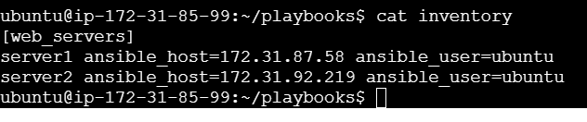

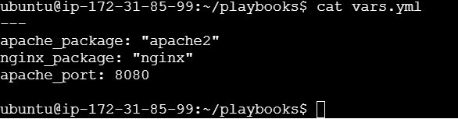

---

- name: Install and Configure Apache & Nginx on Ubuntu

hosts: web_servers

become: yes

vars_files:

- vars.yml

tasks:

- name: Install Apache and Nginx

apt:

name: "{{ item }}"

state: present

update_cache: yes

loop:

- "{{ apache_package }}"

- "{{ nginx_package }}"

- name: Change Apache port

lineinfile:

path: /etc/apache2/ports.conf

regexp: "^Listen "

line: "Listen {{ apache_port }}"

notify: Restart Apache

handlers:

- name: Restart Apache

service:

name: apache2

state: restarted

- name: Restart Nginx

service:

name: nginx

state: restarted

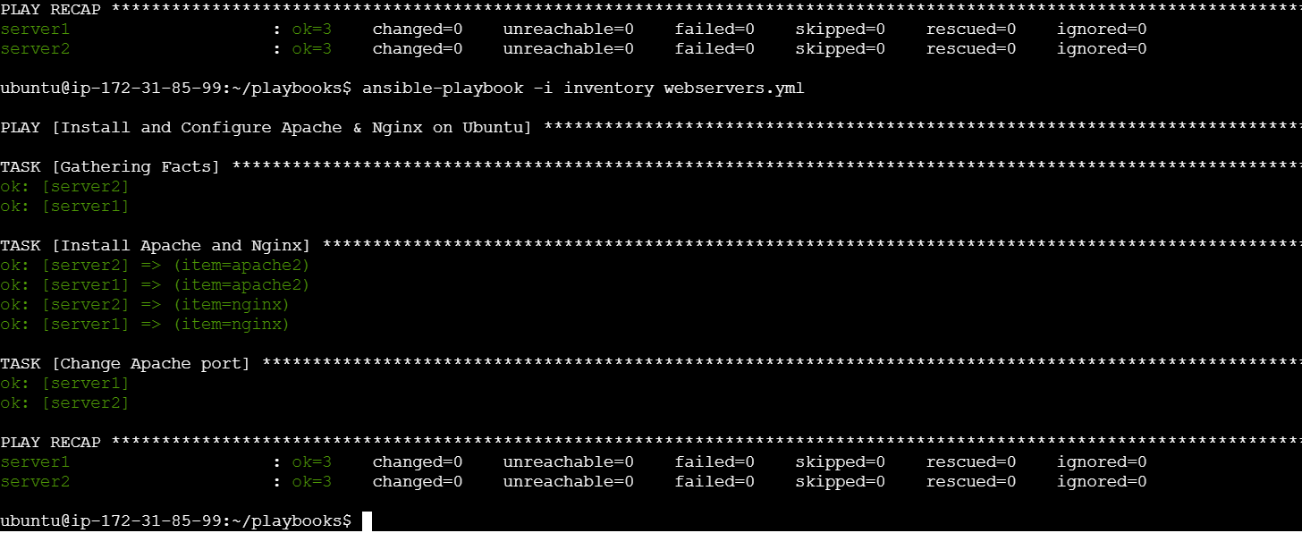

2) Ansible playbook to create 10 different directories with minimal code and directory names should be

passed as variables.

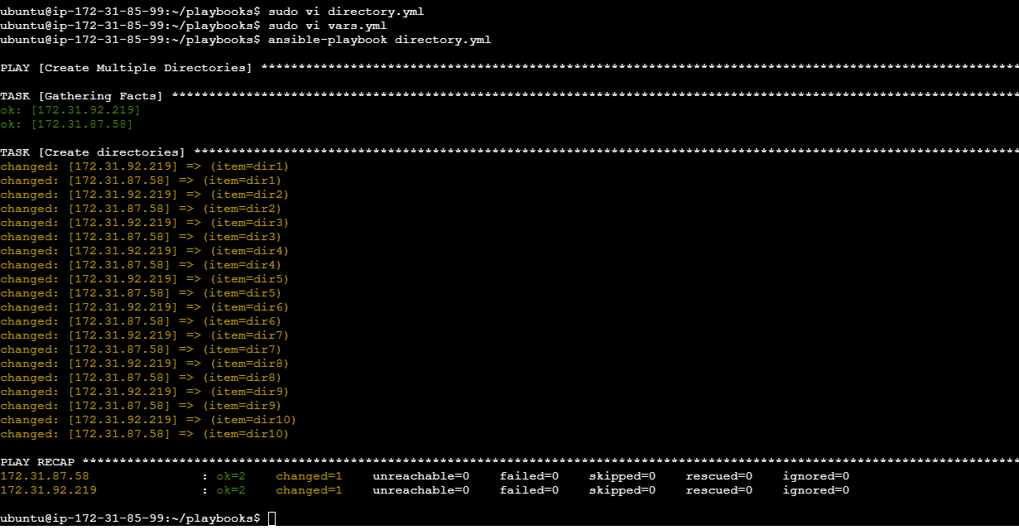

---

dir_names:

- dir1

- dir2

- dir3

- dir4

- dir5

- dir6

- dir7

- dir8

- dir9

- dir10

---

- name: Create Multiple Directories

hosts: all

become: yes

vars_files:

- vars.yml

tasks:

- name: Create directories

file:

path: "/tmp/{{ item }}"

state: directory

loop: "{{ dir_names }}"

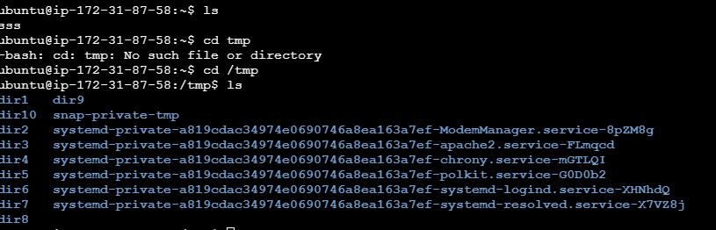

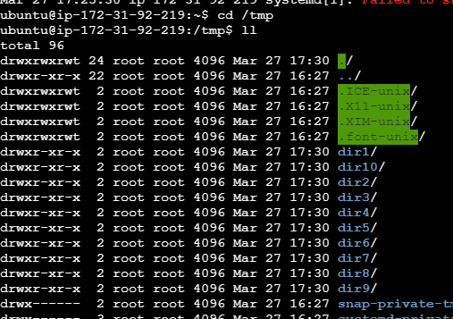

3) Ansible playbook to copy ssh-keygen from master to worker nodes.

Note:

a)Provision new 3 ec2 machines, one master and two worker nodes.

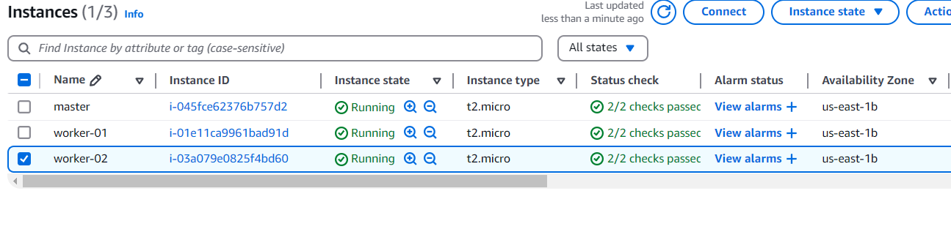

b)Create a common user called ansadm and provide sudo privileges on 3 ec2 instances.

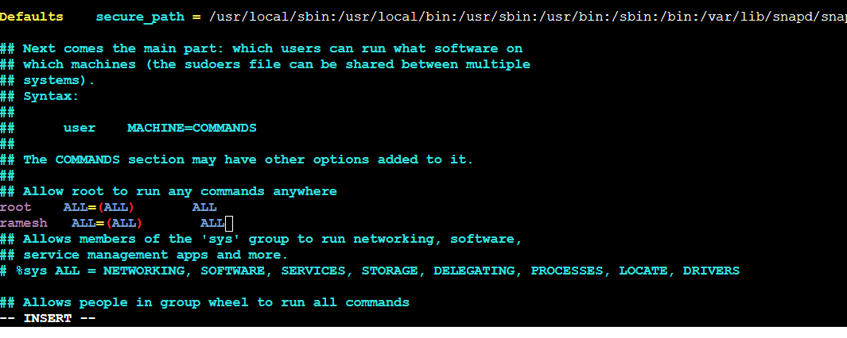

c)Create ssh-keygen in master and your playbook should copy the keygen making it password less

Authentication.

[ansadm@ip-172-31-18-171 ansible-setup]$ cat

inventory.ini ssh_key_setup.yml

[ansadm@ip-172-31-18-171 ansible-setup]$ cat inventory.ini

[workers]

worker1 ansible_host=172.31.18.82 ansible_user=ansadm ansible_ssh_pass=linux

worker2 ansible_host=172.31.25.164 ansible_user=ansadm ansible_ssh_pass=linux

[ansadm@ip-172-31-18-171 ansible-setup]$ cat ssh_key_setup.yml

---

- name: Copy SSH Key to Worker Nodes

hosts: workers

become: true

tasks:

- name: Install OpenSSH if not installed

yum:

name: openssh

state: present

- name: Create .ssh directory

file:

path: /home/ansadm/.ssh

state: directory

owner: ansadm

group: ansadm

mode: '0700'

- name: Copy SSH Key

copy:

src: /home/ansadm/.ssh/id_rsa.pub

dest: /home/ansadm/.ssh/authorized_keys

owner: ansadm

group: ansadm

mode: '0600'

- name: Ensure correct SSH permissions

command: chmod 600 /home/ansadm/.ssh/authorized_keys

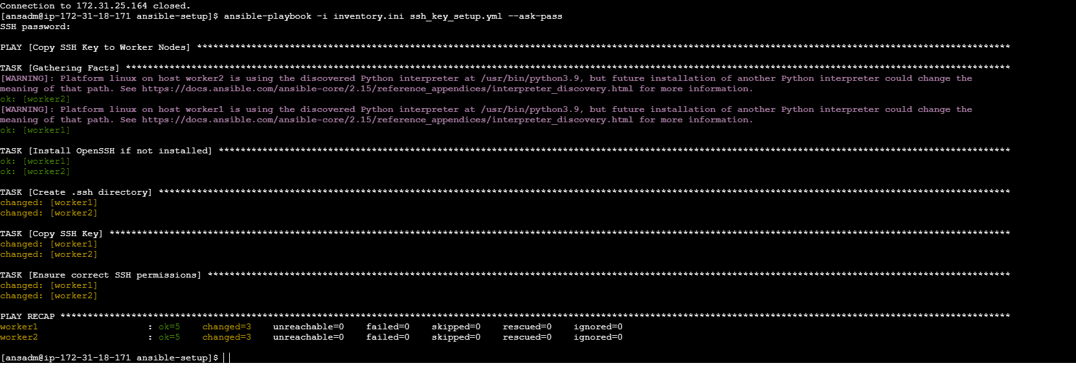

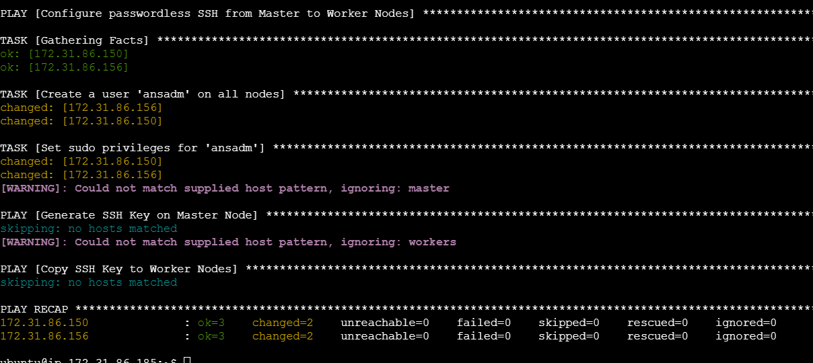

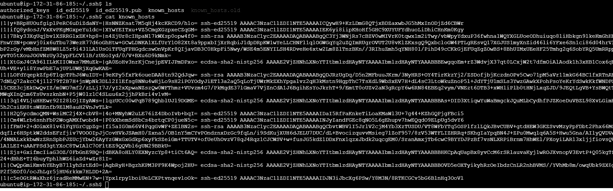

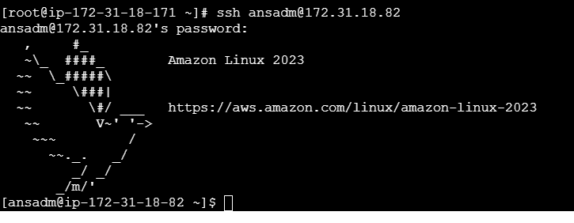

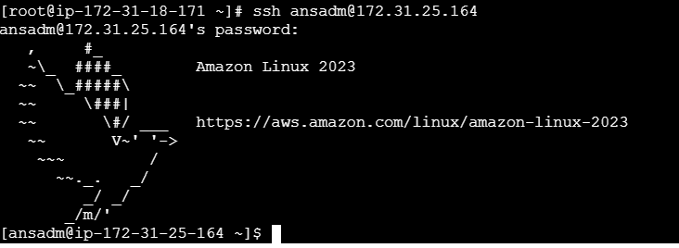

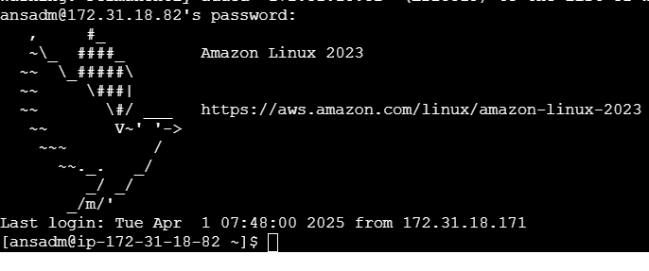

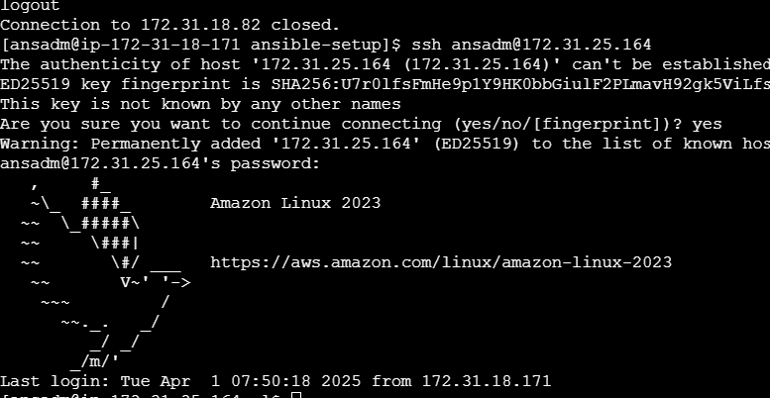

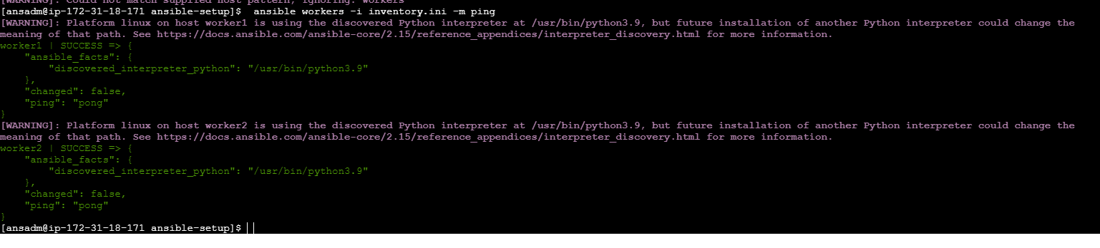

4) Ansible playbook to inject ansible vault variables.

---

- name: Inject Ansible Vault Variables

hosts: all

become: yes

vars_files:

- vault.yml

tasks:

- name: Display Vault Variables

debug:

msg:

- "Database Password: {{ name }}"

- "API Key: {{ password }}"

